1. User Stories List
Actor | Feature | Priority
Campus Community User | Register account | Useful
Campus Community User | Reset forgotten password | Important
Campus Community User | Close own Lost Item report when item is found | Useful
Security Office Staff | Search and filter reports by type, status, date, and location | Critical
Campus Administrator | View all reports | Critical
Campus Administrator | Manage roles | Critical
Campus Administrator | Monitor usage and generate summary reports | Critical
Campus Administrator | View system activity | Important

2. Story Points
Actor | Feature | Story Points
Campus Community User | Register account | 5
Campus Community User | Reset forgotten password | 3
Campus Community User | Close own Lost Item report when item is found | 3
Security Office Staff | Search and filter reports by type, status, date, and location | 8
Campus Administrator | View all reports | 3
Campus Administrator | Manage roles | 3
Campus Administrator | Monitor usage and generate summary reports | 8
Campus Administrator | View system activity | 5

3. Acceptance Criteria
User Story | Acceptance Criteria | Priority
As a Campus Community User, I want to register my account so that I can report lost or found items | Given I’m not registered  - When I submit valid registration details  - Then a new user is created and stored  Given I enter an email address that already exists in the database  - When I submit the registration form  - Then I receive an error and the account is not created  Given I submit invalid data  - When I attempt to register  - An error returns and account are not created | Useful
As a Campus Community User, I want to be able to reset my password so that I can recover my account to report lost or find items | Given a campus community user visits the static website and doesn’t remember the password  - When they open /password-reset/, they enter their email address and click send reset link,  - Then a reset link is generated and sent to the email  Given I have a valid reset token  - When I submit a new password  - Then my password is updated  Given I have an invalid token  - When I attempt to reset the password  - Then the system rejects the password and doesn’t update | Important
As a Campus Community User, I want to be able to close own lost item report when item is found so that I can contribute to only showing the relevant ones | Given the campus community user wants to close own lost item report  - When they mark it as closed  - Then the report status is changed to “Closed”  Given that I’m a campus community user and I’m not the report owner for the report I want to close  - When I mark it as closed  - Then the system denies the action | Useful
As a Security Office Staff, I want to search & filter by reports by type, status, date, and location so that I can see the correct reports I am looking for | Given there are reports in the directory  - When I apply filters  - Then the specified reports based on the filters are returned  Given no reports match the filter  - When a filter is applied  - Then an empty string is returned | Critical
As a Campus Administrator, I want to view all reports so that I cannot just exercise my full rights as an admin but also to ensure the reports are accurate | Given I’m the admin  - When I request all reports  - Then I receive all reports regardless  Given I’m not the admin  - When I request all reports  - Access is denied | Critical
As a Campus Administrator, I want to manage roles so that I ensure the system is secure and all users are practicing least privilege | Given I’m the admin  - When I assign or update a user’s role  - Then the role is updated in the system  Given a user’s role is changed  - When they perform an action  - Then the permissions are reflected on the role and its rights.  Given an invalid role is provided  - When the admin attempts to assign it  - System rejects the request | Critical
As a Campus Administrator, I want to monitor usage and generate summary reports so that I can track user’s actions in the directory | Given I’m the admin  - When I request a usage report  - Then the set of data is returned  Given I specify filters  - When I request a summary report  - Then the set of data is reflected upon those filters | Critical
As a Campus Administrator, I want to view system activity so that I can analyze system performance | Given I’m the admin  - When I access system logs  - Then I can view system activity  Given logs exist  - When I filter the system logs  - Then I can view system activity that is reflected from those filters | Important

4. Scrum Meeting Days
Day | Time
Monday | 9:00 AM – 9:30
WeD | 9:00 AM – 9:30
Fridays | 9:00 AM -9:30

5. Future Story Points
Actor | Feature | Story Points
Security Office Staff | View All reports, including unpublished ones | 3
Campus Administrator | Override report status decisions when necessary | 3
Campus Administrator | Manage System-level settings | 8

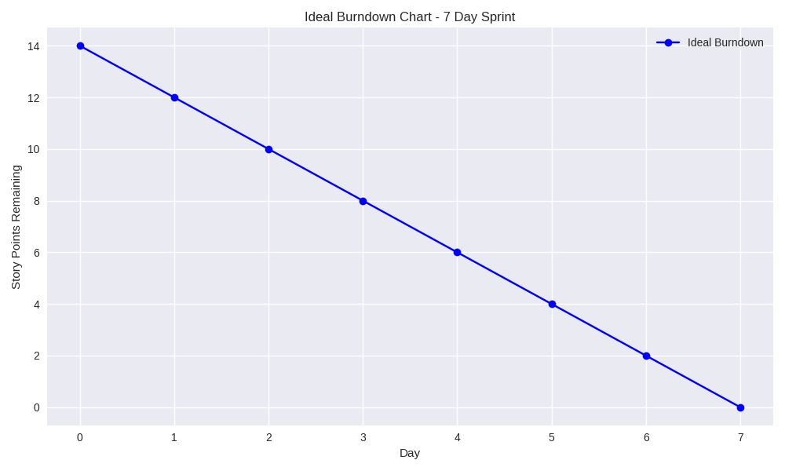

Test Cases Sprint 3

User Story 1:
Campus Community User can register account
Test Case | Input | Expected Output | Actual Output
1 (Success) | Precondition: User does not have an account  1. Enter valid username  2. Enter valid email  3. Enter password  4. Click “Register” | The system creates a new account and confirms successful registration | Creates account and prompt for verification and confirms successful registration
2 (Failure) | Precondition: User is on registration page  1. Leave required fields empty  2. Click Ringster | The system prevents registration and displays validation errors | Shows alert message as “Please fill out this field.”

User Story 2:
Campus Community User can reset forgotten password
Test Case | Input | Expected Output | Actual Output
1 (Success) | Precondition: User is on password reset page  1. Enter registered email  2. Click reset password | The system sends a password reset link or allows password reset | To be implemented
2 (Failure) | Precondition: User is on password reset page  1. Enter unregistered email  2. Click “Reset Password” | The system displays an error indicating email is not found | Prompt “Please enter a correct username and password.”

User Story 3:
Campus Community User can close own lost item report when item is found
Test Case | Input | Expected Output | Actual Output
1 (Success) | Precondition: User is logged in and owns a Lost Item report  1. Open report  2. Click “Item Found” | The system updates and marks the report as closed | First the status needs to be approved before closing, currently it would be in “pending” status
2 (Failure) | Precondition: User is logged in but does not own the report.  1. Open another user’s report  2. Verify “Close Report” button is disabled | The system prevents closing reports not owned by the user. | No option to edit reports if user doesn’t own a report

User Story 4:
Security Office Staff can search and filter reports by type, status, date, and location
Test Case | Input | Expected Output | Actual Output
1 (Success) | Precondition: Staff User is logged in.  - Click filters  - Click Search | The system displays all published reports matching the selected filters. | The system displays all published reports matching the selected filters.
2 (Failure) | Precondition: Staff user is logged in.  1. Click filters with no data  2. Click Search | The system shows displays no results | System shows “No reports match the selected scope and filters.”

User Story 5:
Campus Administrator can view all reports
Test Case | Input | Expected Output | Actual Output
1 (Success) | Precondition: Admin user is logged in  1. Navigate to “All Reports” Page | The system displays all reports in the system | The system displays all reports in the system
2 (Failure) | Precondition: Campus Community user or Security office staff user is logged in.  1. Attempt to navigate to “All Reports” page | The system denies access to the unauthorized users. | To be tested

User Story 6:
Campus Admins can manage roles
Test Case | Input | Expected Output | Actual Output
1 (Success) | Precondition: Admin user is logged in.  1. Select a user  2. Change role  3. Click "Save" | The system updates users role successfully | To be tested
2 (Failure) | Precondition: Campus Community user or Security office staff logged in  1. Attempt to change roles | The system prevents role modification and restricts access | -

User Story 7:
Campus Administrator can monitor usage and generate summary reports
Test Case | Input | Expected Output | Actual Output
1 (Success) | Precondition: Admin user is logged in. | The system generates and displays usage summary data | System summary is visible
2 (Failure) | Precondition: Regular user is logged in. | The system blocks the user | -

User Story 8:
Campus Amdinistrator can vie system activity
Test Case | Input | Expected Output | Actual Output
1 (Success) | Precondition: Admin user is logged in | The system displays logs of system activity | To be tested
2 (Failure) | Precondition: Staff user or Campus user is logged in | The system denies access | -

